COSC 603 APG
Software Testing and Maintenance
Spring 2016

Project #3 – Unit Testing with JUnit

From: Marlene Encinas
Task 3 – A Little More Advanced - Rectangle.
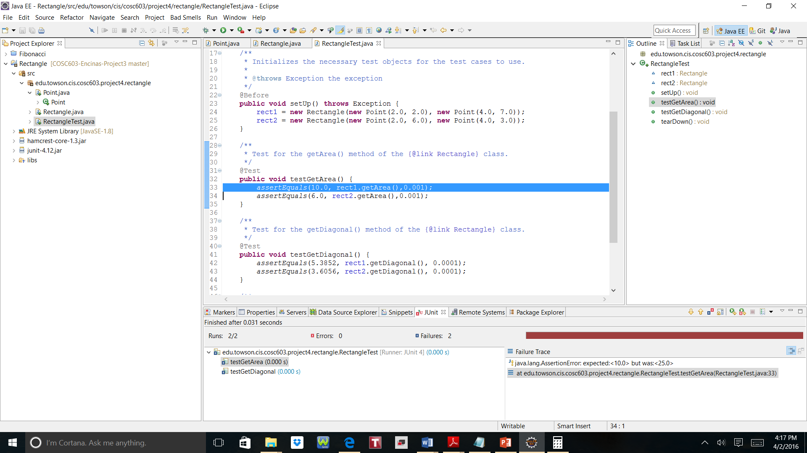
The test failed in the first Unit Test when testing getArea() for points (2.0, 2.0) and (4.0, 7.0).
The error is inside getArea() in the formula to calculate Rectangle’s area. The current coes is adding width and height instead of multiplying them.
The error is in the Point class under the constructor when initializing point. The y value is assigned to both parameters x and y.
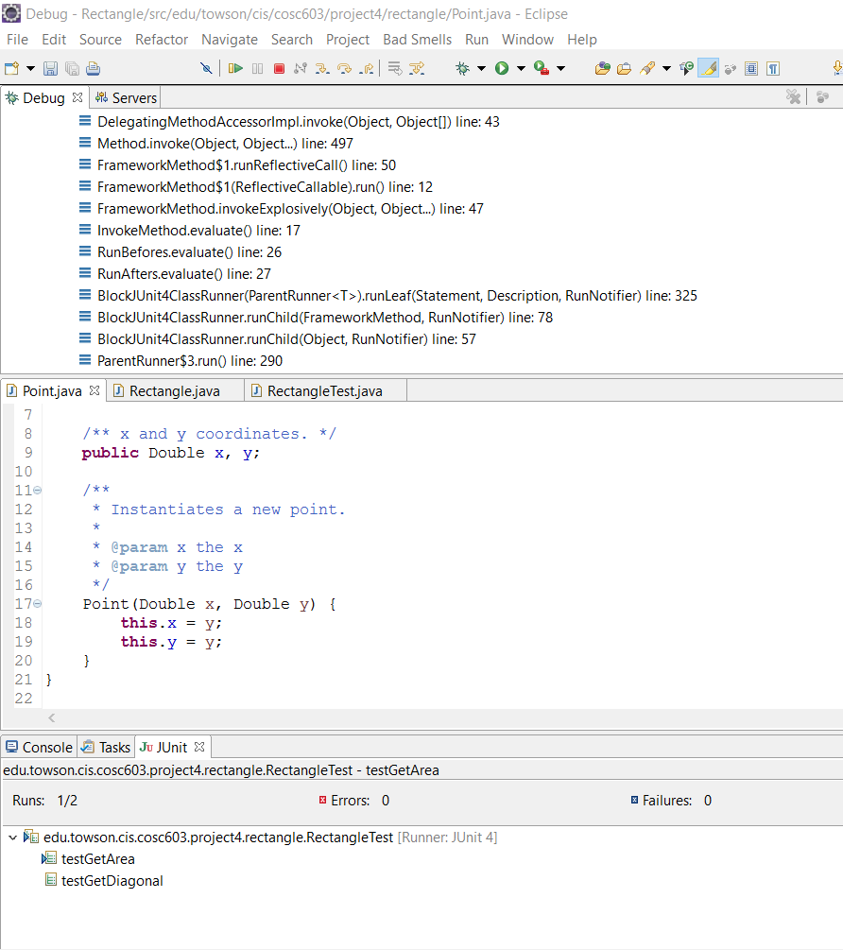
After correcting, I ran the Junit test and got the green bar:
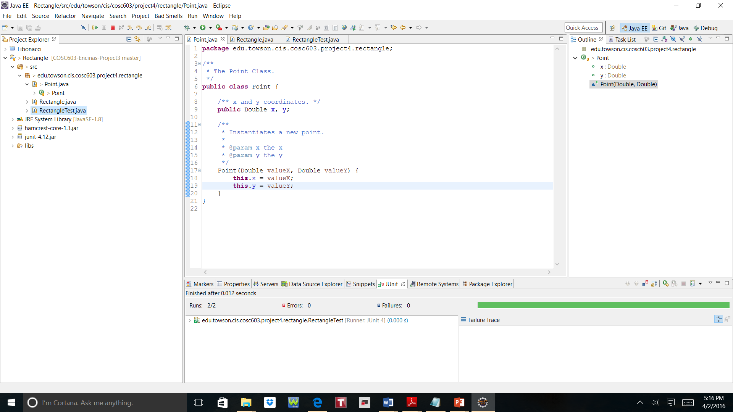
Ways to improve the code to make it higher quality and easier to spot bugs:
In Point.java:
- User more meaningful parameters names in the constructor Point. Instead of x and y, I would use valueX and valueY, this way it will make aware to the developer that is typing two different parameters and assigning them to different entities.
- User more explicit comments
In Rectangle.java:
Define two properties as part of Rectangle class: width which will store the width value of a rectangle and height which will store the height value of a rectangle.
When instantiating a Rectangle, define the values of width and height.
getAfrea();
- Remove the calculation area from the return value. Split the formula into a more meaningful form by assigning its parts into two Rectangle properties width and height.
- Insert more meaningful variables names. Express area calculation using these two more meaningful property names width and height and place it into an areaRec variable. Return areaRec.
- We also can add a wrapper to validate if the values input are defining a rectangle. If not then getArea() can throw an exception, otherwise it can proceed to calculate area.
- if ((width == 0) || (height ==0))
- {
- throw new ArithmeticException("This is not a rectangle. Invalid!");
- }
- else
- {
- areaRec = Math.abs(width * height);// return the absolute value
- }
- Add meaningful comments as part of documentation
getDiagonal();
- Since the width and height are calculated when a Rectangle is instantiated, then these two values can be used to calculate the diagonal.
